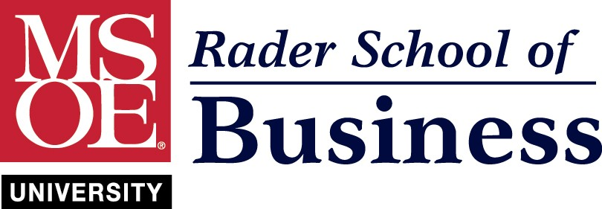

Rader School of Business – Accounting Career Paths Guide

As I step into my new role at MSOE, I have identified an opportunity to broaden students’ understanding of the accounting profession and the career paths available to them. Through conversations with students, I have realized that current perceptions of accounting careers are relatively limited. For example, some students view accounting primarily as bookkeeping, or believe AI will replace accounting jobs.
Project problem or opportunity:

This creates an opportunity to develop a more structured and engaging way to help students understand the variety of roles within the accounting profession and the skills needed for success. By creating an Accounting Career Paths Guide, students will gain an understanding of the opportunities available, including public accounting, corporate accounting, tax, nonprofit accounting, and leadership roles.

This initiative also creates an opportunity to reach students outside of the Rader School of Business, especially students who started at MSOE in engineering, and later realized they want to pursue something else. This would give MSOE the opportunity to introduce these students to accounting, which may increase retention.

The overall goal is to improve student awareness, confidence, and interest in accounting.

Projected start date: June 2026

Client/Customer name: Rader School of Business

Project sponsor and stakeholders:
• Sponsor: Ruth Barratt, Ph.D. – Chair of the Rader School of Business

• Stakeholders: Rader School of Business Students, MSOE Students, Rader School of Business Faculty, Industry Speakers, Potential employers

Team members: N/A – At this stage, I am the primary team member. However, I may seek input from stakeholders.

Project manager: I (Alyssa Henke) will serve as the project manager

Prepared by: Alyssa Henke

Date written/Version number: May 19, 2026

Project objective: This project will result in the creation of the Accounting Career Paths Guide, which aims to enhance students’ understanding of the accounting profession and job opportunities. The focus of the project is on helping current business students and non-business students who may be reconsidering their major. Project deliverables include an Accounting Career Paths Guide that is two to three pages, at least three five-minute classroom presentations to increase awareness, and one to two industry speakers to increase interest and build confidence.

The project is expected to be completed by April 2027. By this date, the Accounting Career Paths Guide will be published, classroom presentations will have been delivered, and at least one industry speaker event will have been held. Student feedback will also be collected and reviewed.

The estimated budget is $0 in incremental costs.

Major deliverables: Major deliverables include:

- An Accounting Career Paths Guide
- Classroom presentations
- Industry speakers

Reason for the project: The primary reason for this project is to increase awareness of accounting opportunities and equip students with tools needed to make relevant decisions about whether they will pursue a career in accounting. I believe that this project will deliver value by increasing student engagement and decision-making. Additionally, it may help retain students who may be reconsidering their original major. I plan to measure value by performing pre and post presentation surveys to gauge whether students have a better understanding of accounting career paths. I also believe that value can be measured by students level of engagement, including whether they express interest in learning more, attend speaker events, or use the Accounting Career Paths Guide.

Project ideas: Another project idea that I considered was partnering with accounting firms and companies to host MSOE students for office visits or networking events. This would give students exposure, but I think before we do something like this, we need to build stronger student awareness and interest in accounting career paths.

Constraints: The project will be constrained by students, faculty, and accounting professionals’ availability to participate in presentations and use the Guide. Additionally, the deliverables will need to leverage MSOE resources. Lastly, since the accounting program is still growing, it may take time for the initiative to gain momentum.

Assumptions: My project assumes that students are interested in and would benefit from broadening their understanding of the accounting profession. For non-business students, the project assumes that some students may be reconsidering their major but still want to remain at MSOE. I am also making the assumption that stakeholders may be willing to support the initiative by allowing me to present in their class and/or participating in speaker events.

Risks: I believe a key risk is that students are not interested in the materials and/or sessions, leading to low student engagement. Additionally, there are quite a few potential career paths in accounting, which may lead to students feeling overwhelmed if I provide too much information.

Approvals (Sponsors, key stakeholders, steering committee) I have discussed this project with Ruth Barratt, RSOB Chair, and have her support.

Approvals typically include sponsors, key stakeholders, and customers who are approving and authorizing the project to be initiated and may have final approval for the delivered product or service. Signatures denote commitment of resources, funds, and support for the project planning process. They will be included in the review of the project scope of work.
Name | Role | Signature | Date
Ruth Barratt | Chair

